Data Visualisation Project Stand-up 1

Nguyen Gia Binh - 104219428

Student

Swinburne University of Technology

Hanoi, Vietnam

[104219428@student.swin.edu.au](mailto:104219428@student.swin.edu.au)

Nguyen Quang Dao - 104211864

Student

Swinburne University of Technology

Hanoi, Vietnam

[104211864@student.swin.edu.au](mailto:104060260@student.swin.edu.au)

I) INTRODUCTION

This document outlines the work we have done to prepare for the first project stand-up session. We have established a github repositoty with both members to working on the project, a discord server was also open for the purpose of posting potential documents and data files that we might use for the project, a confluence/jira page was also created to record what we have done and the reason behind our work on the project.

II) GitHub Page

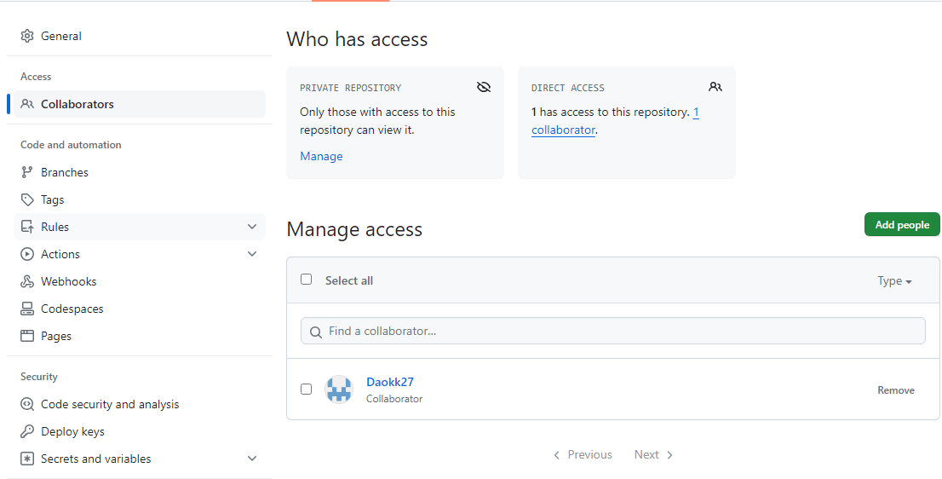

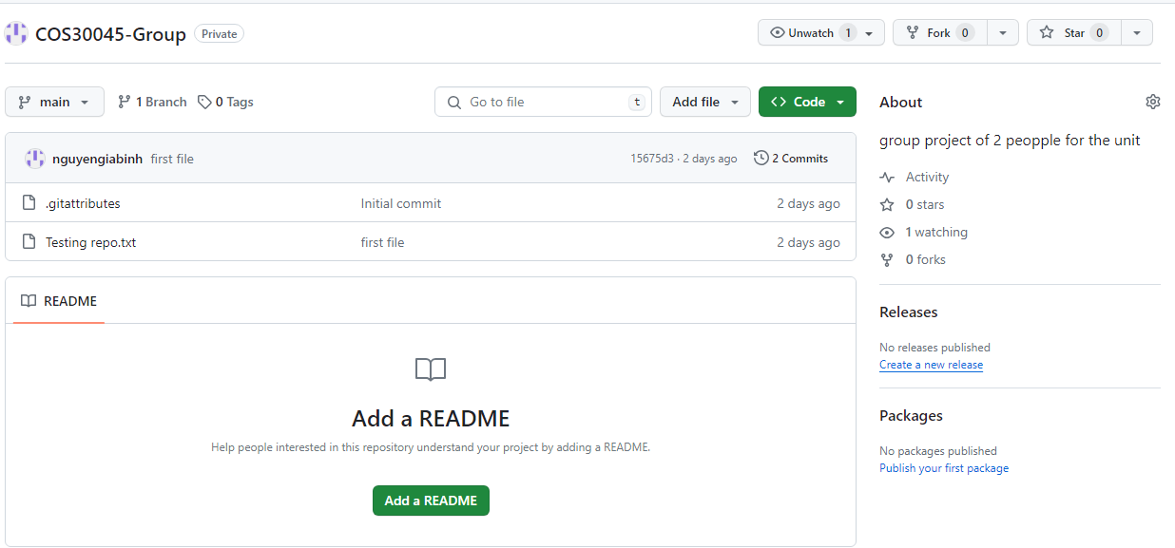

III) Discord Server

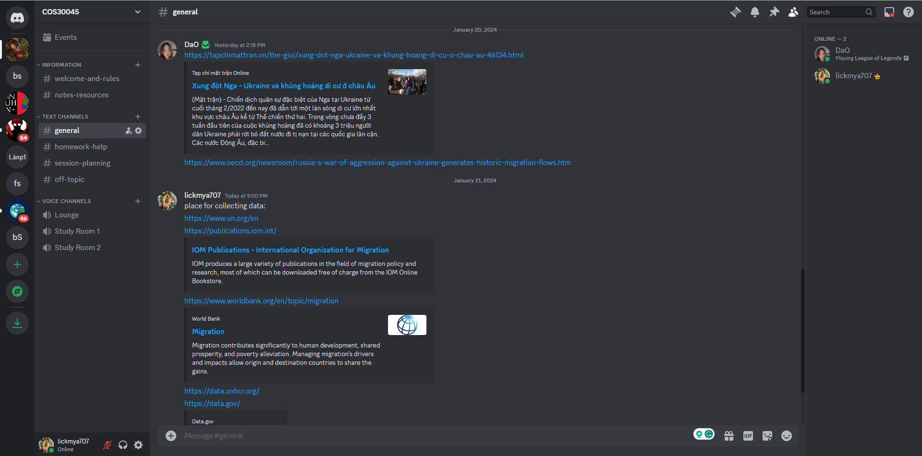

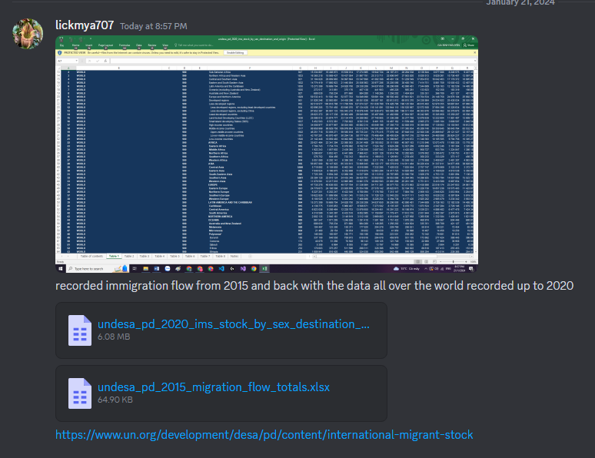

IV) Confluence/Jira space

